

TAYLOR’S UWE DUAL AWARDS PROGRAMMES
APRIL 2024 SEMESTER
(ITS62904) DATABASE SYSTEMS
ASSESSMENT 3
(GROUP ASSIGNMENT)
30%

No | Student Name | Student  ID | Date | Signature | Contribution  Details | Score
1 | MD NAIM UL HASAN | 0370302 | 12/7/24 |  | DESIGN ,DEPLOYMENT  EER  Physical Model
2 | WANG SHUN | 0371331 | 12/7/24 |  | DESIGN ,DEPL  YMENT  DESIGNING USEFUL REPORT  PartB  PartD  ER  Mysql
3 | WUBIN | 0374383 | 12/7/24 |  | SQL REPORT  PartE  PartB  Mysql
4 | WANG QIDONG | 0373257 | 12/7/24 |  | SQL Conteons REPORT  PartE  PartB  Mysql
5 | Wang Yuntian | 0371739 | 12/7/24 |  | SQL REPORT  PartB  PartC
6 | Zhou JianLong | 0370509 | 12/7/24 |  | SQL REPORT  PartB  PartC

1. Design: 7
1.1 ER 7
1.2 Physical Model 7
1.3 Explanation: 8
1.3.1 Member 8
1.3.2 Instructor 9
1.3.3Class 9
1.3.4Equipment 9
1.3.5 Attendance 9
1.3.6 EquipmentRental 10
1.3.7 PersonalTraining 10
1.3.8 Package 10
1.3.9 PointsTracker 10
1.3.10 Merchandise 11
1.3.11 Friend 11
1.4 Relationships 11
1.4.1 Member to Attendance 11
1.4.2 Class to Instructor 11
1.4.3 Member to EquipmentRental 11
1.4.4 Equipment to EquipmentRental 12
1.4.5 Member to PersonalTraining 12
1.4.6 Instructor to PersonalTraining 12
1.4.7 Member to Package 12
1.4.8 Member to PointsTracker 12
1.4.9 Member to Merchandise 12
1.4.10 Member to Friend 12
1.5 EER 13
1.6 Explanation:Entities and Attributes 13
1.6.1 Member 13
1.6.2 Class 14
1.6.3 Instructor 14
1.6.4 Equipment 14
1.6.5 Attendance 14
1.6.7 EquipmentRental 15
1.6.8 PersonalTraining 15
1.6.9 Package 15
1.6.10 PointsTracker 15
1.6.11 Merchandise 16
1.6.12 Friend 16
1.7 Relationships 16
1.7.1Member 16
1.7.2 Class 17
1.7.3Instructor 17
1.7.4Equipment 17
2 Deployment: 17
2.1 CODE: 18
3 SQL Report: 22
3.1. Provide a list of members with the most class attendance in the past month and the most popular class by average attendance in the past quarter. 22
3.1.1 Report Overview 23
3.2 MYSQL statement 23
3.3Write a SQL query to list all equipment that is currently unavailable for rent. 24
3.3.1Report Overview 25
3.3.2：Report Analysis 25
3.4 Compute a 10% discount on rental fees for all equipment. Calculate the potential revenue increase for equipment rentals in 2024 with the discount price. 26
3.4.1Report Overview 27
3.4.2Report Analysis 27
3.4.3Report Overview 27
3.4.4Report Analysis 27
3.5：Generate a report showing the total number of courses offered by each instructor 28
3.5.1Report Overview 28
3.5.2Report Analysis 29
3.6 Identify the instructors who will teach the most courses in 2023 29
3.6.1 Report Overview 30
3.6.2 Report Analysis 30
3.7 Provide a point accrual trend for different member types and activities (class attendance, rentals, PT sessions) across brands. Identify members with the highest point balances and their preferred point earning methods. 31
3.7.1 Report Overview 32
3.7.2 Report Analysis 32
3.8 Identify the top three best-selling packages (considering both Fit & Fab and Silver Sneakers) and analyze any correlations with brand associations or guest pass usage. 33
3.8.1 Report Overview 34
3.8.2Report Analysis 34
3.9：Identify the most successful “bring a friend” campaigns by analyzing which members refer new members (covering all membership types) and the points earned. 35
3.9.1 Report Overview 36
3.9.2Report Analysis 36
3.10 Analyse the "class satisfaction scores" data to identify trends in member preferences and suggest improvements to class offerings based on brand, intensity level, and user feedback. 37
3.10.1Report Overview: 38
3.10.2Report Analysis 39
3.11 Uncover the secrets of member engagement! List the members who earned the most points in the past quarter, categorized by points earned through exercise, challenges, and healthy eating habits 41
3.11.1Report Overview 41
3.11.2 Report Analysis 41
4 ANALYSING DATABASE STRUCTURE AND DESIGNING USEFUL REPORTS 42
4.1Member points accumulation report 42
4.1.1 Report Overview 43
4.1.2 Report Analysis 44
4.2 Equipment Utilization Report 45
4.2.1 Report Overview 46
4.2.2 Report Analysis 46
4.3 Membership Type Analysis Report 46
4.3.1 Report Overview 47
4.3.2 Report Analysis 47
4.4 Instructor Satisfaction Analysis Report 48
4.4.1Report Overview 48
4.4.2Report Analysis 48
4.5 Sales Analysis Report 49
4.5.1 Report Overview 49
4.5.2 Report Analysis 50
5. Unforeseen challenges: 50
5.1 Create a new table to store information about outdoor fitness boot camp courses. It should contain: 51
5.2 also need to create a new attendance table to record the attendance of members. It should contain： 52
5.3 And we need to change the fitness machine table in mysql. Because some devices cannot be owned outdoors 52
6.REFERENCE 54

1. Design:

1.1 ER
Entity-Relationship Diagram (ERD) - Map the entities with appropriate relationships.
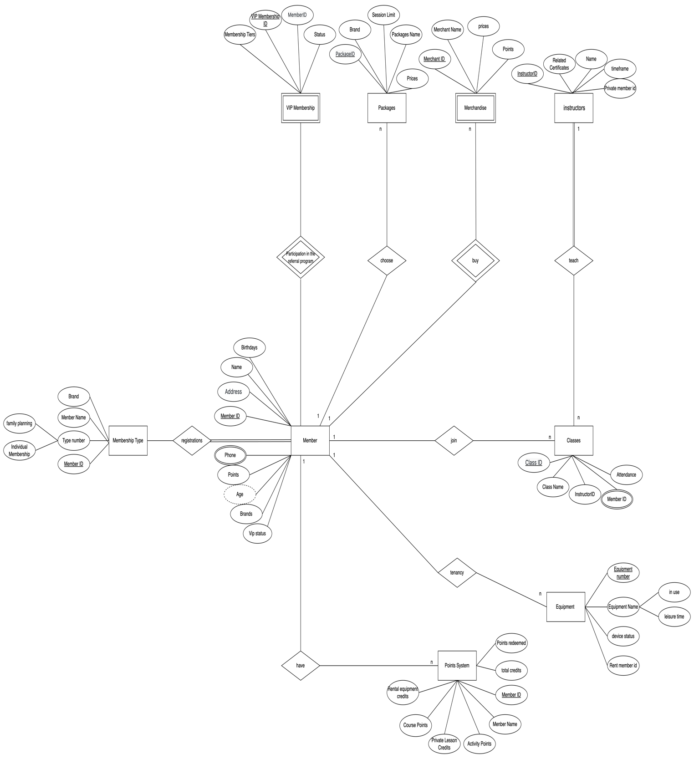

1.2 Physical Model
Provide the necessary information for a relational database model to ensure data integrity (primary keys, foreign. keys, data types).
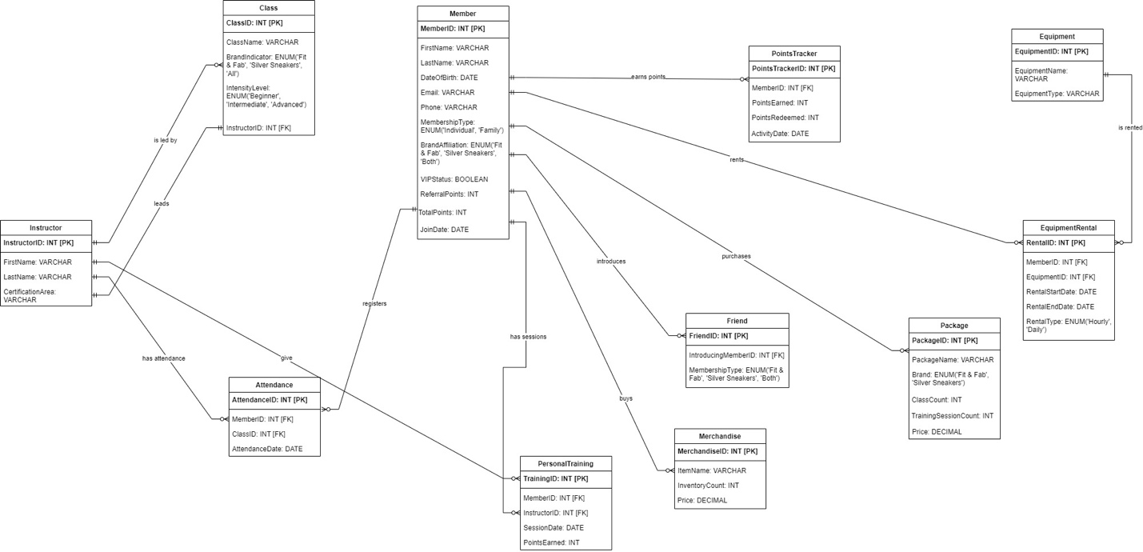

1.3 Explanation:
Tables and Attributes:

1.3.1 Member
  - MemberID: Each member's unique identification is stored in the INT, Primary Key.
  - FirstName: The member's initial name is VARCHAR(50).
  - LastName: The member's last name is VARCHAR(50).
  - DateOfBirth: This is the member's birthdate.
  - Email: VARCHAR(100) - Member's email address.
  - Phone: VARCHAR(20) - Member's phone number.
  - MembershipType: VARCHAR(20), CHECK - Can be 'Individual' or 'Family'.
  - BrandAffiliation: VARCHAR(20), CHECK - Can be 'Fit & Fab', 'Silver Sneakers', or 'Both'.
  - VIPStatus: BIT - Indicates if the member is a VIP.
  - ReferralPoints: INT - Points earned through referrals.
  - TotalPoints: INT - Total points earned by the member.
  - JoinDate: DATE - Date when the member joined.

1.3.2 Instructor
  - InstructorID: INT, Primary Key - Unique identifier for each instructor.
  - FirstName: VARCHAR(50) - Instructor's first name.
  - LastName: VARCHAR(50) - Instructor's last name.
  - CertificationArea: VARCHAR(100) - Area of certification for the instructor.

1.3.3Class
  - ClassID: INT, Primary Key - Unique identifier for each class.
  - ClassName: VARCHAR(50) - Name of the class.
  - BrandIndicator: VARCHAR(20), CHECK - Can be 'Fit & Fab', 'Silver Sneakers', or 'All'.
  - IntensityLevel: VARCHAR(20), CHECK - Can be 'Beginner', 'Intermediate', or 'Advanced'.
  - InstructorID: INT, Foreign Key - References Instructor(InstructorID).

1.3.4Equipment
  - EquipmentID: INT, Primary Key - Unique identifier for each piece of equipment.
  - EquipmentName: VARCHAR(50) - Name of the equipment.
  - EquipmentType: VARCHAR(50) - Type of equipment.

1.3.5 Attendance
  - AttendanceID: A unique identifier for every attendance record is the INT, or primary key.
  - MemberID: Foreign Key (INT) - References Member (MemberID).
  - ClassID: INT stands for Foreign Key with References Class (ClassID).
  - AttendanceDate: DATE: The attendance date.

1.3.6 EquipmentRental
  - RentalID: A distinct identifier for every rental record is the INT, or primary key.
  - MemberID: Foreign Key - References Member (MemberID), INT.
  - EquipmentID: Equipment(EquipmentID) is referenced by the foreign key INT.
  - RentalStartDate: DATE: The rental's commencement date.
  - RentalEndDate: DATE: The rental's expiration date.
  - RentalType: VARCHAR(10), CHECK - Can be 'Hourly' or 'Daily'.

1.3.7 PersonalTraining
  - TrainingID: A distinct identification for every training session is the INT, or primary key.
  - MemberID: Foreign Key - References Member (MemberID), INT.
  - InstructorID: INT, Foreign Key - References Instructor(InstructorID).
  - SessionDate: DATE - Date of the training session.
  - PointsEarned: INT - Points earned for the session.

1.3.8 Package
  - PackageID: INT, Primary Key - Unique identifier for each package.
  - PackageName: VARCHAR(50) - Name of the package.
  - Brand: VARCHAR(20), CHECK - Can be 'Fit & Fab' or 'Silver Sneakers'.
  - ClassCount: INT - Number of classes included in the package.
  - TrainingSessionCount: INT - Number of training sessions included in the package.
  - Price: DECIMAL(10, 2) - Price of the package.

1.3.9 PointsTracker
  - PointsTrackerID: INT, Primary Key - Unique identifier for each points tracker record.
  - MemberID: INT, Foreign Key - References Member(MemberID).
  - PointsEarned: INT - Points earned.
  - PointsRedeemed: INT - Points redeemed.
  - ActivityDate: DATE - Date of the points activity.

1.3.10 Merchandise
  - MerchandiseID: INT, Primary Key - Unique identifier for each merchandise item.
  - ItemName: VARCHAR(50) - Name of the merchandise item.
  - InventoryCount: INT - Inventory count of the item.
  - Price: DECIMAL(10, 2) - Price of the item.

1.3.11 Friend
  - FriendID: INT, Primary Key - Unique identifier for each friend record.
  - IntroducingMemberID: INT, Foreign Key - References Member(MemberID).
  - MembershipType: VARCHAR(20), CHECK - Can be 'Fit & Fab', 'Silver Sneakers', or 'Both'.

1.4 Relationships

1.4.1 Member to Attendance
  - A member can register for multiple classes (one-to-many).
  - Foreign Key: MemberID in Attendance references MemberID in Member.

1.4.2 Class to Instructor
  - A class is led by one instructor (many-to-one).
  - Foreign Key: InstructorID in Class references InstructorID in Instructor.

1.4.3 Member to EquipmentRental
  - A member can rent multiple pieces of equipment (one-to-many).
  - Foreign Key: MemberID in EquipmentRental references MemberID in Member.

1.4.4 Equipment to EquipmentRental
  - A piece of equipment can be rented multiple times (one-to-many).
  - Foreign Key: EquipmentID in EquipmentRental references EquipmentID in Equipment.

1.4.5 Member to PersonalTraining
  - A member can have multiple personal training sessions (one-to-many).
  - Foreign Key: MemberID in PersonalTraining references MemberID in Member.

1.4.6 Instructor to PersonalTraining
  - An instructor can conduct multiple personal training sessions (one-to-many).
  - Foreign Key: InstructorID in PersonalTraining references InstructorID in Instructor.

1.4.7 Member to Package
  - A member can purchase multiple packages (one-to-many).
  - No direct foreign key relationship needed as the relationship is implicit in usage and purchase tracking.

1.4.8 Member to PointsTracker
  - A member can earn and redeem points multiple times (one-to-many).
  - Foreign Key: MemberID in PointsTracker references MemberID in Member.

1.4.9 Member to Merchandise
  - A member can purchase multiple merchandise items (one-to-many).
  - No direct foreign key relationship needed as the relationship is implicit in purchase records.

1.4.10 Member to Friend
  - A member can introduce multiple friends (one-to-many).
  - Foreign Key: IntroducingMemberID in Friend references MemberID in Member.

1.5 EER
Enhanced Entity-Relationship Diagram (EER) – Capture the intricate relationships between entities and consider the concept of inheritance for brand specific packages.

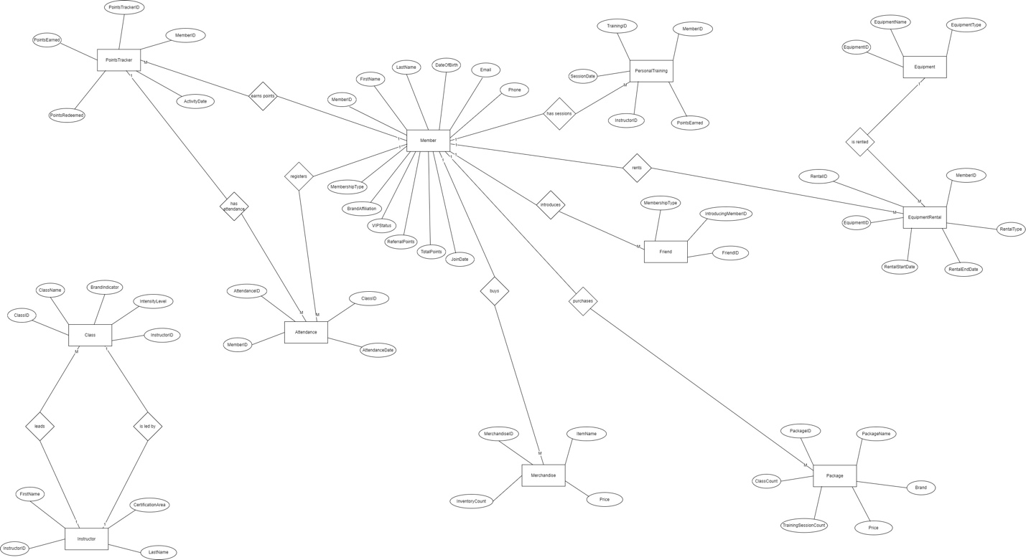

1.6 Explanation:Entities and Attributes

1.6.1 Member
  - MemberID: individual member identification number (Primary Key).
  - FirstName: First name of the participant.
  - LastName: Member's last name.
  - DateOfBirth: The member's birthdate.
  - Email: Member's email address.
  - Phone: Member's phone number.
  - MembershipType: Type of membership (Individual or Family).
  - BrandAffiliation: Brand affiliation (Fit & Fab, Silver Sneakers, or Both).
  - VIPStatus: Boolean indicating if the member is a VIP.
  - ReferralPoints: Points earned through referrals.
  - TotalPoints: Total points earned by the member.
  - JoinDate: Date when the member joined.

1.6.2 Class
  - ClassID: Unique identifier for each class (Primary Key).
  - ClassName: Name of the class (e.g., yoga, pilates).
  - BrandIndicator: Brand associated with the class (Fit & Fab, Silver Sneakers, or All).
  - IntensityLevel: Difficulty level of the class (Beginner, Intermediate, Advanced).
  - InstructorID: Unique identifier for the instructor (Foreign Key).

1.6.3 Instructor
  - InstructorID: Unique identifier for each instructor (Primary Key).
  - FirstName: First name of the instructor.
  - LastName: Last name of the instructor.
  - CertificationArea: Areas in which the instructor is certified (e.g., yoga, strength training).

1.6.4 Equipment
  - EquipmentID: Unique identifier for each piece of equipment (Primary Key).
  - EquipmentName: Name of the equipment (e.g., treadmill, weight bench).
  - EquipmentType: Type of equipment.

1.6.5 Attendance
  - AttendanceID: Unique identifier for each attendance record (Primary Key).
  - MemberID: Unique identifier for the member (Foreign Key).
  - ClassID: Unique identifier for the class (Foreign Key).
  - AttendanceDate: Date of attendance.

1.6.7 EquipmentRental
  - RentalID: Unique identifier for each equipment rental (Primary Key).
  - MemberID: Unique identifier for the member (Foreign Key).
  - EquipmentID: Unique identifier for the equipment (Foreign Key).
  - RentalStartDate: Start date of the rental period.
  - RentalEndDate: End date of the rental period.
  - RentalType: Type of rental (Hourly, Daily).

1.6.8 PersonalTraining
  - TrainingID: Unique identifier for each personal training session (Primary Key).
  - MemberID: Unique identifier for the member (Foreign Key).
  - InstructorID: Unique identifier for the instructor (Foreign Key).
  - SessionDate: Date of the training session.
  - PointsEarned: Points earned during the session.

1.6.9 Package
  - PackageID: Unique identifier for each package (Primary Key).
  - PackageName: Name of the package (e.g., 10-class pass).
  - Brand: Brand associated with the package (Fit & Fab, Silver Sneakers).
  - ClassCount: Number of classes included in the package.
  - TrainingSessionCount: Number of training sessions included in the package.
  - Price: Price of the package.

1.6.10 PointsTracker
  - PointsTrackerID: Unique identifier for each points tracking record (Primary Key).
  - MemberID: Unique identifier for the member (Foreign Key).
  - PointsEarned: Points earned in a specific activity.
  - PointsRedeemed: Points redeemed in a specific activity.
  - ActivityDate: Date of the activity.

1.6.11 Merchandise
  - MerchandiseID: Unique identifier for each merchandise item (Primary Key).
  - ItemName: Name of the merchandise item.
  - InventoryCount: Number of items available in inventory.
  - Price: Price of the merchandise item.

1.6.12 Friend
  - FriendID: Unique identifier for each friend record (Primary Key).
  - IntroducingMemberID: Unique identifier for the member who introduced the friend (Foreign Key).
  - MembershipType: Membership type chosen by the friend (Fit & Fab, Silver Sneakers, Both).

1.7 Relationships

1.7.1Member
  - Attendance: A member can register for many classes. Each attendance record links a member to a class.
  - EquipmentRental: A member can rent many pieces of equipment. Each rental record links a member to an equipment item.
  - PersonalTraining: A member can have many personal training sessions. Each session links a member to an instructor.
  - Package: A member can purchase many packages. Each package record links a member to a package.
  - PointsTracker: A member can earn and redeem points through various activities. Each points tracking record links a member to points earned or redeemed.
  - Merchandise: A member can buy many merchandise items. Each merchandise purchase record links a member to a merchandise item.
  - Friend: A member can introduce many friends. Each friend record links a member to a friend they introduced.

1.7.2 Class
  - Instructor: A class is led by one instructor, and an instructor can lead many classes.
  - Attendance: A class can have many members attending. Each attendance record links a class to a member.

1.7.3Instructor
  - Class: An instructor can lead many classes.
  - PersonalTraining: An instructor can conduct many personal training sessions. Each session links an instructor to a member.

1.7.4Equipment
  - EquipmentRental: An equipment item can be rented by many members. Each rental record links an equipment item to a member.

2 Deployment:
Implementation: create database, tables and populate the data (each table should have 20+rows of valid records if it’s applicable). This may not be applicable for all table but ensure thatthe sample data reflects the complex membership structure, package options, and "Bring a Friend" program. Ensure data across tables is consistent and adheres to the defined rules. Member and class tables should have at least 30 records.

2.1 CODE:
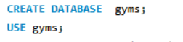
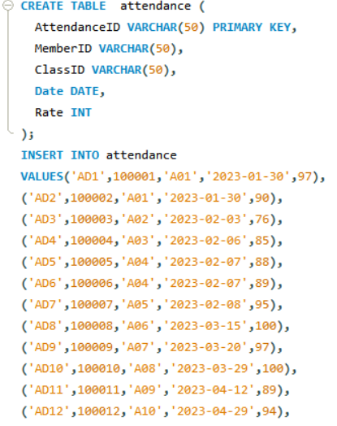
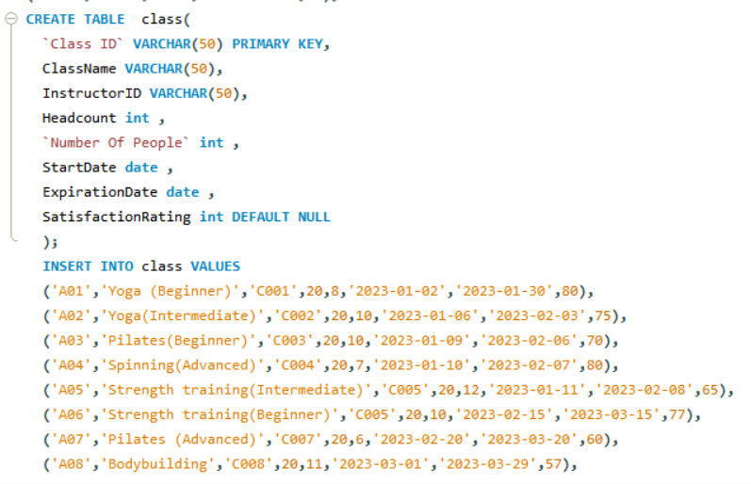
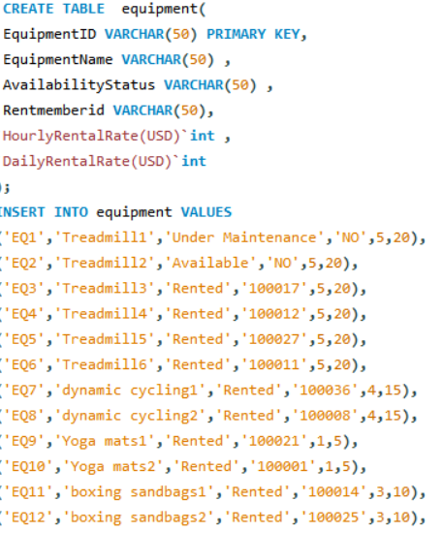
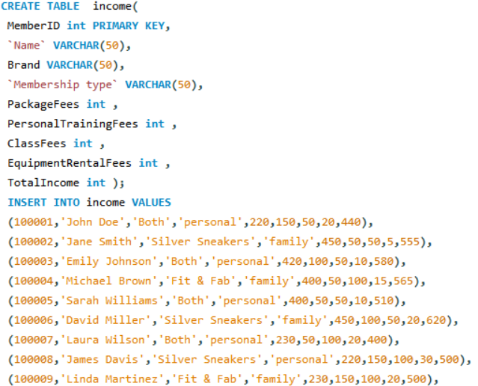

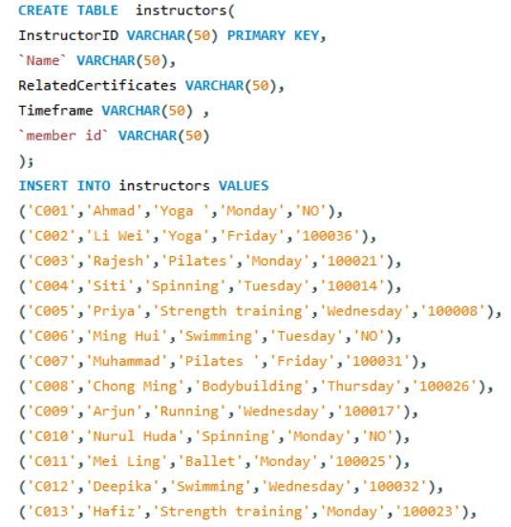
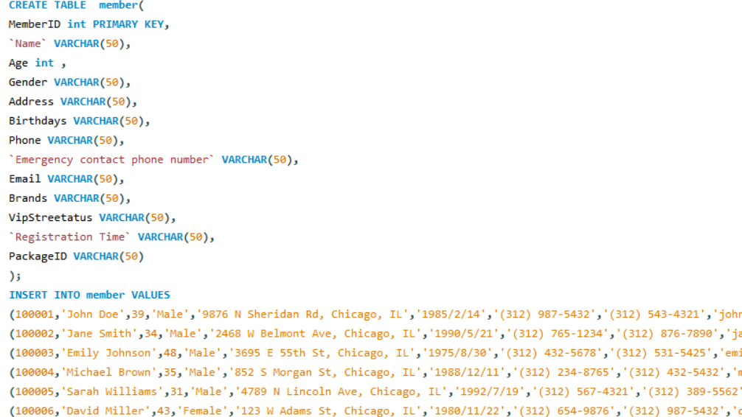
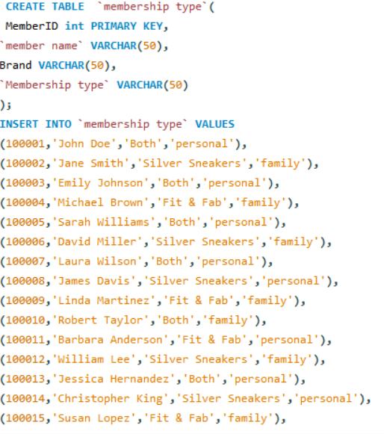
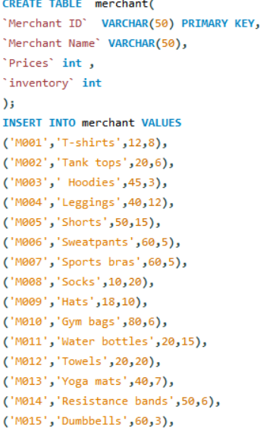
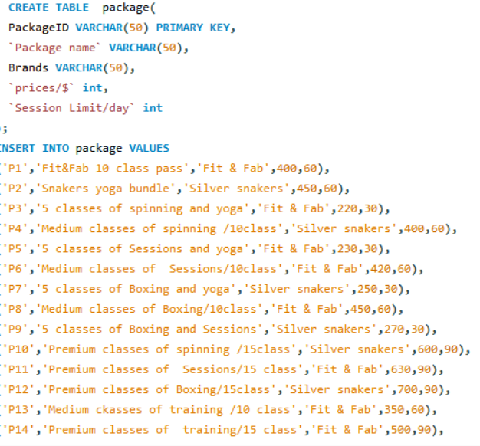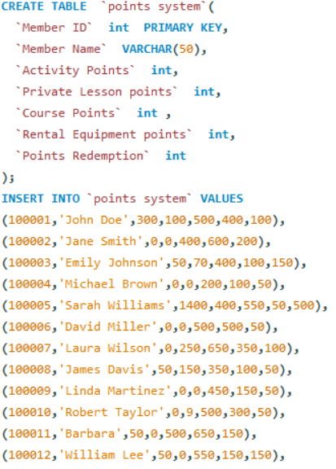

3 SQL Report:

3.1. Provide a list of members with the most class attendance in the past month and the most popular class by average attendance in the past quarter.
SELECT MemberID FROM attendance
WHERE YEAR(Date) = 2024 AND MONTH(Date) = 2
ORDER BY Rate DESC
LIMIT 1;
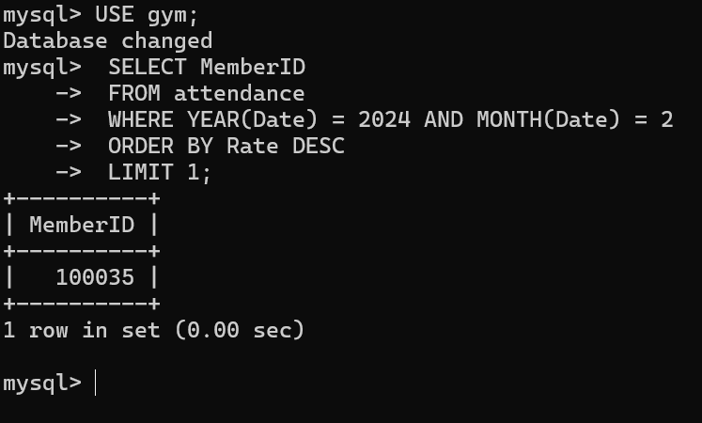

3.1.1 Report Overview
The purpose of this report is to count the members who attended classes and received the highest ratings in February 2024. Through this statistics, fitness centers can identify active and well-received members for rewards or recognition, thereby increasing member participation and loyalty.
3.1.2 Report Analysis
For the high-rated courses among the courses we published: According to the data in our observation table, the courses with the highest ratings among all the courses published are very popular among our members. This result shows that the teaching content of these courses, the level of the coaches who teach this course, the professional knowledge reserves and the arrangement of the courses have been highly satisfied and recognized by our members.

3.2 MYSQL statement
SELECT `class`.`Class Name`, `avg_rate`.average_rate
FROM (SELECT `Class ID`, AVG(CONVERT(SUBSTRING_INDEX(`Rate`, '%', 1), SIGNED)) AS average_rate
FROM `attendance`
GROUP BY `Class ID`) AS `avg_rate` JOIN `class` ON `class`.`Class ID` = `avg_rate`.`Class ID`
ORDER BY
`avg_rate`.average_rate DESC
LIMIT 1;
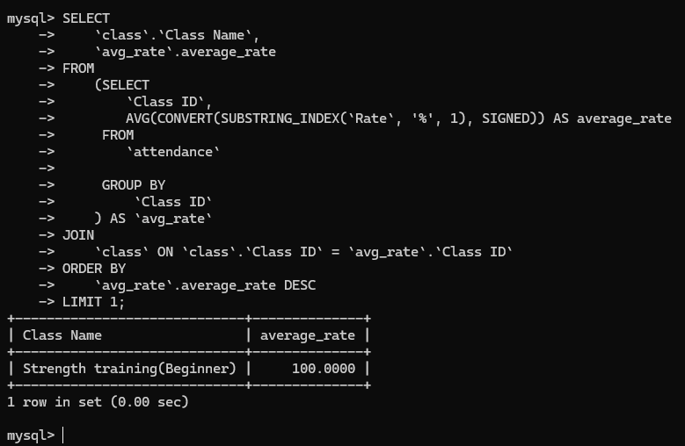
3.2.1Report Overview
This report aims to analyze the average ratings of fitness center classes, with a focus on identifying the highest-rated classes. This analysis can help understand which classes are most popular, providing data support for class improvements and member satisfaction.
3.2.2Report Analysis
For the satisfaction of our members: For the high ratings given by members, these contents reflect the satisfaction of the members with the courses we published. This information can help our fitness center management, so that we can more intuitively understand what we have done well and have been recognized by members, and do the same in other courses. In other places, we can learn from each other's strengths and weaknesses, so as to do better and get recognition from the majority of members.

3.3Write a SQL query to list all equipment that is currently unavailable for rent.
SELECT
EquipmentID,EquipmentName，AvailabilityStatus
FROM
Equipment
WHERE
AvailabilityStatus != 'Available';
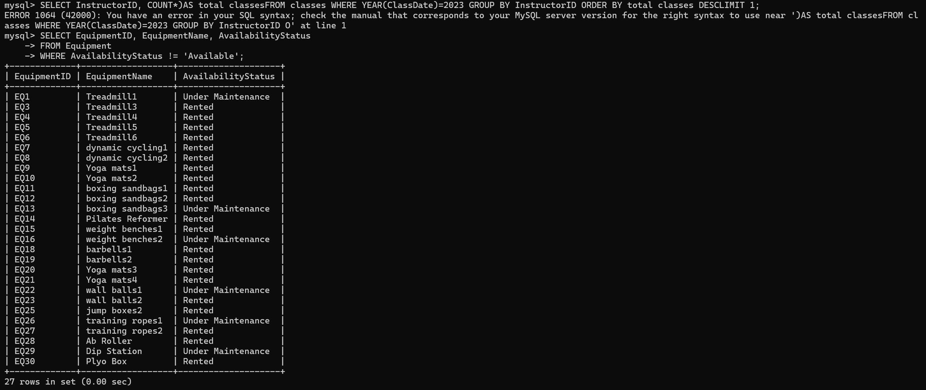

3.3.1Report Overview
This report queries the availability status of equipment and retrieves information about equipment that is currently unavailable for rent at the fitness center. Equipment that is unavailable for rent includes equipment that is either idle or under maintenance.

3.3.2：Report Analysis
We effectively select and sort the IDs, names and availability status of all the equipment that are temporarily unavailable for rent in the fitness center through the query report. By analyzing the data in this arrangement table, we can identify the names of the equipment that are currently being rented by members or under maintenance, which effectively provides detailed data support for the usage and maintenance needs of all equipment in our fitness center. By constantly paying attention to the data of unavailable equipment, our fitness center management team can better understand the support and utilization patterns of the equipment, and make decisions about the maintenance schedule of the fitness center equipment, the investment required for subsequent equipment, and the satisfaction and usage rate of the fitness center members.

3.4 Compute a 10% discount on rental fees for all equipment. Calculate the potential revenue increase for equipment rentals in 2024 with the discount price.
SELECT EquipmentID, EquipmentName,
`HourlyRentalRate(USD)` * 0.9 AS DiscountedHourlyRate,
`DailyRentalRate(USD)` * 0.9 AS DiscountedDailyRate
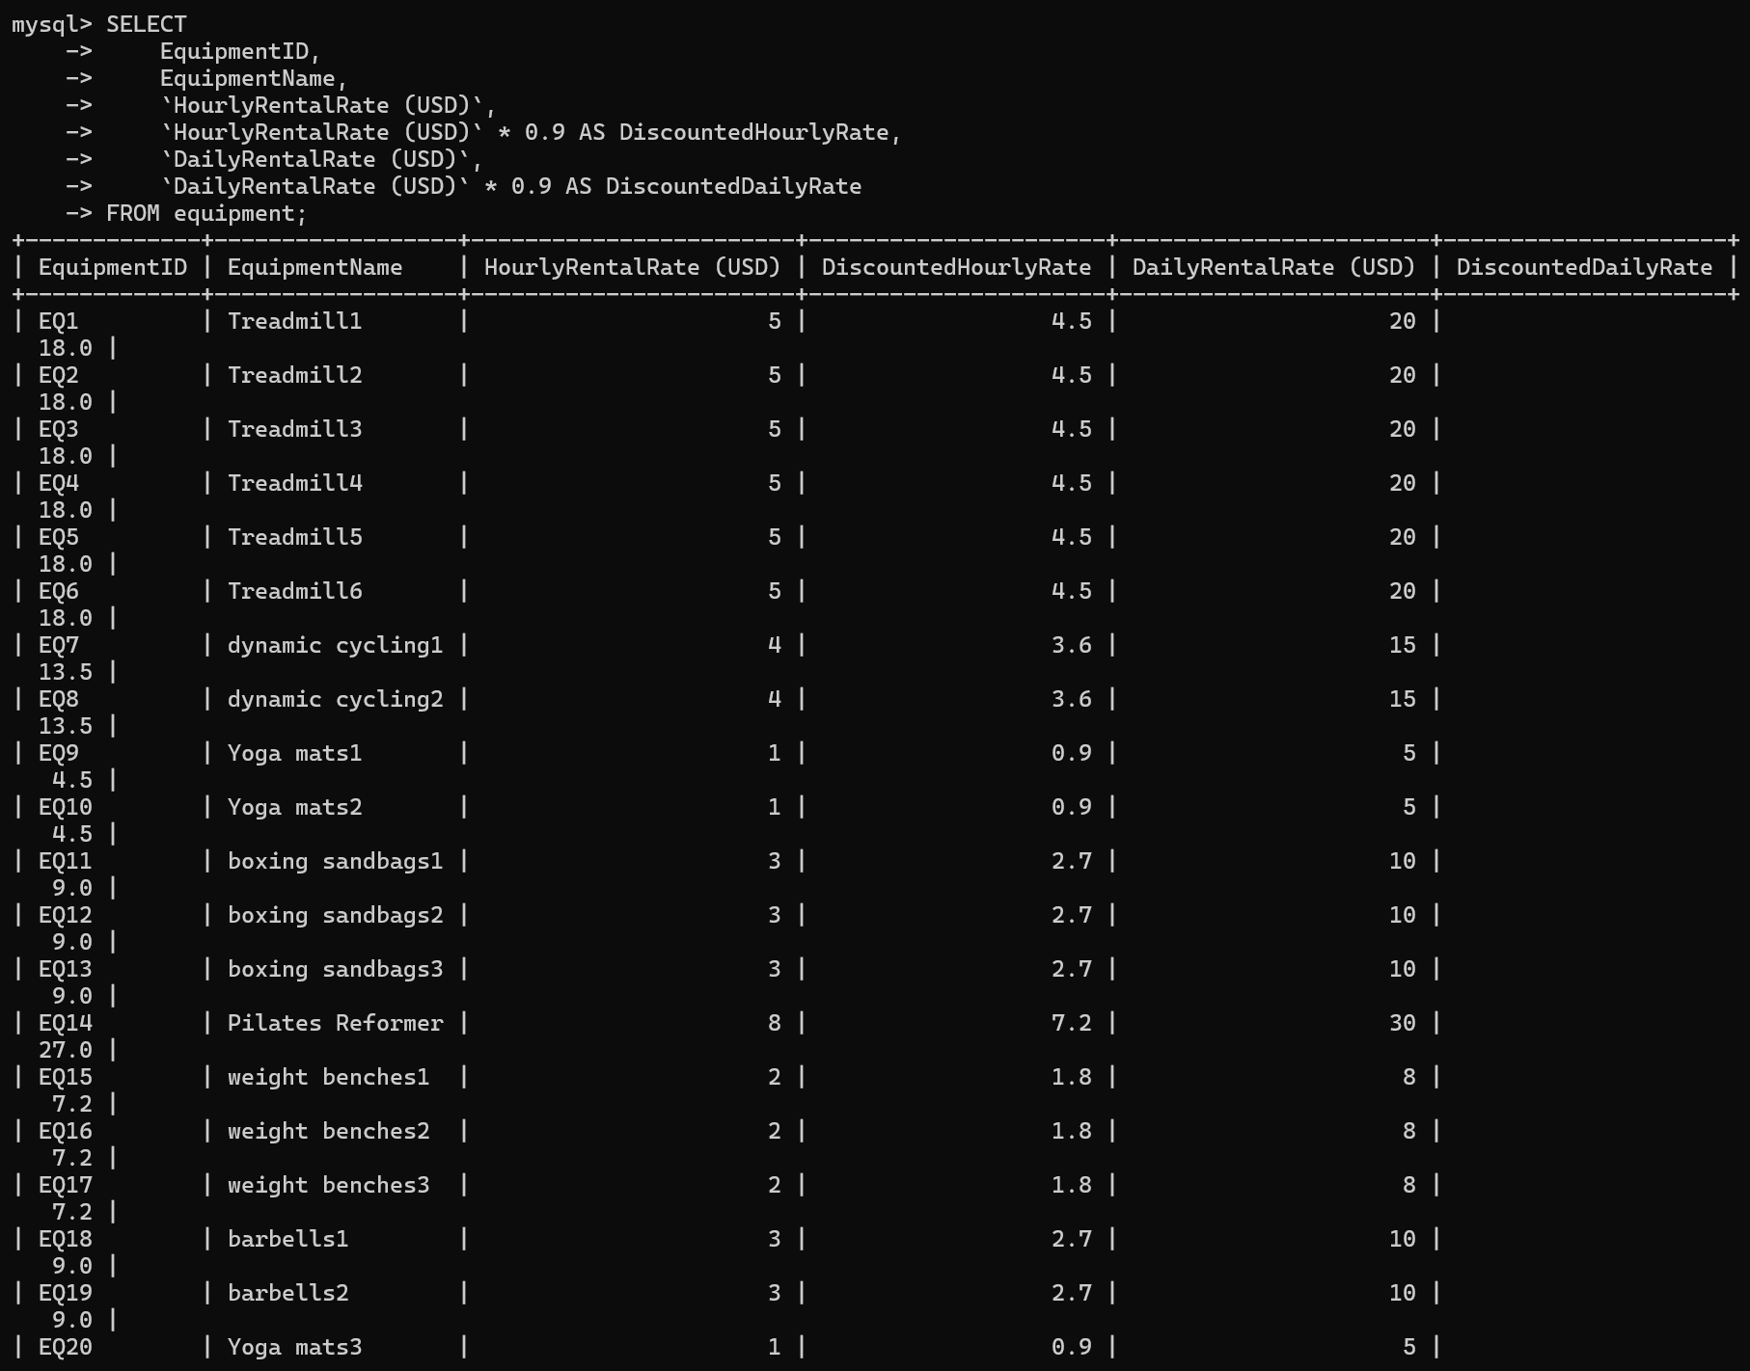
FROM equipment;

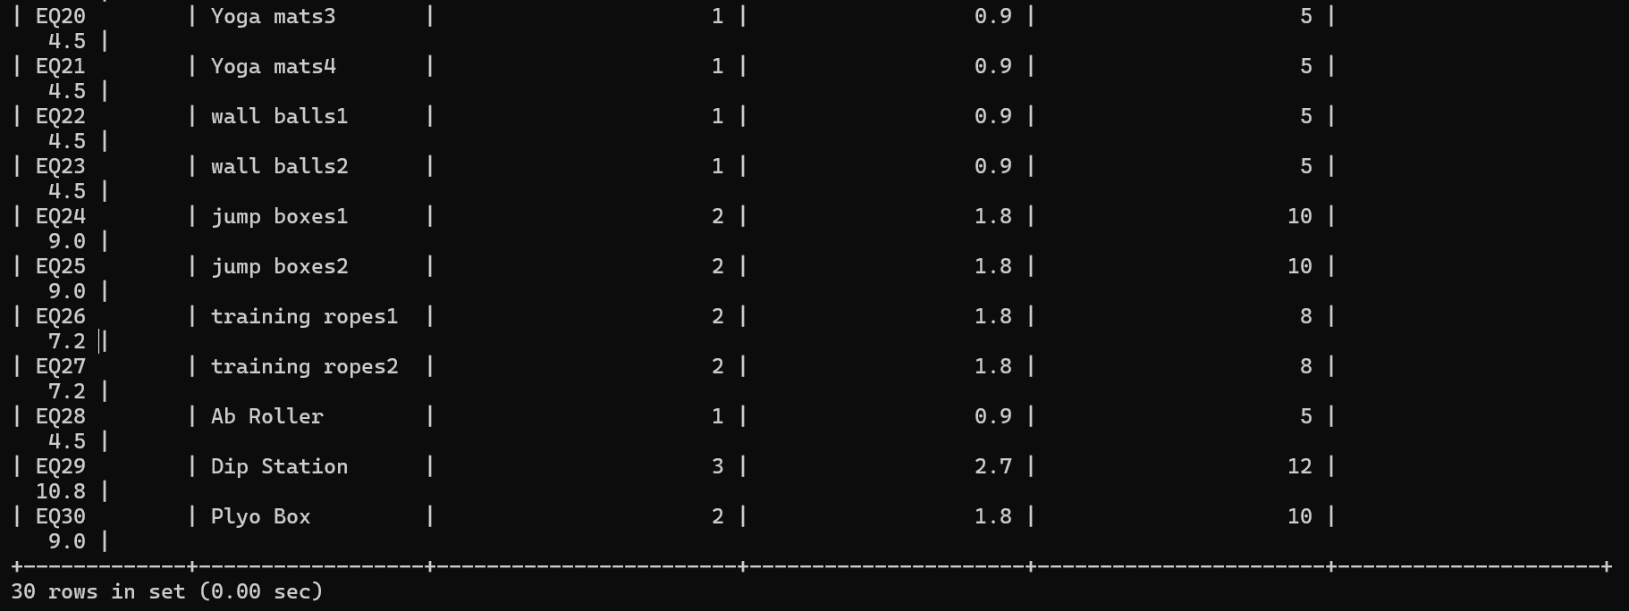

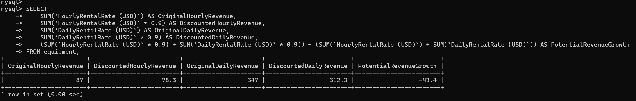

3.4.1Report Overview
our report is to re-evaluate the discounted prices of each piece of equipment in response to a 10% discount on the hourly and daily rates for exercise equipment rentals at all fitness centers.

3.4.2Report Analysis
Through this analysis, we provide fitness centers with clear data support to evaluate the changes in the specific amount of the 10% discount strategy for sports equipment rentals for all fitness centers. This can more intuitively feel the impact of the 10% discount on prices and provide data support for future fitness centers' pricing decisions on sports equipment rentals.

3.4.3Report Overview
By applying discounts to the rental prices of fitness center sports equipment, we can analyze the frequency of fitness center sports equipment rentals and the potential growth and overall revenue growth, and their relationship, thereby providing valuable data and reference for our strategic pricing decisions on fitness center equipment rentals and equipment rental prices.

3.4.4Report Analysis
If a 10% discount on all equipment rentals at a fitness center will lead to a proportional increase in the frequency of equipment rentals at the fitness center. Then a 10% discount on all equipment rentals is expected to significantly increase our fitness center's total equipment rental revenue.
This discount strategy for sports equipment rentals will increase the attractiveness of all our equipment rentals to members, and may also increase the satisfaction of our fitness center's broad membership base, which in turn can increase our total revenue.
Our analysis of the fitness center's 10% discount on equipment rental prices helps the fitness center's management better understand the impact of pricing strategies on the fitness center's total revenue, thereby supporting management to better formulate more effective and correct marketing activities and more accurate pricing decisions.

3.5：Generate a report showing the total number of courses offered by each instructor
SELECT `instructors`.`Name` AS `Instructor Name`, COUNT(`class`.`ClassID`) AS `Total Courses`
FROM `class` JOIN `instructors` ON `class`.`InstructorID` = `instructors`.`InstructorID`
GROUP BY `instructors`.`Name`;
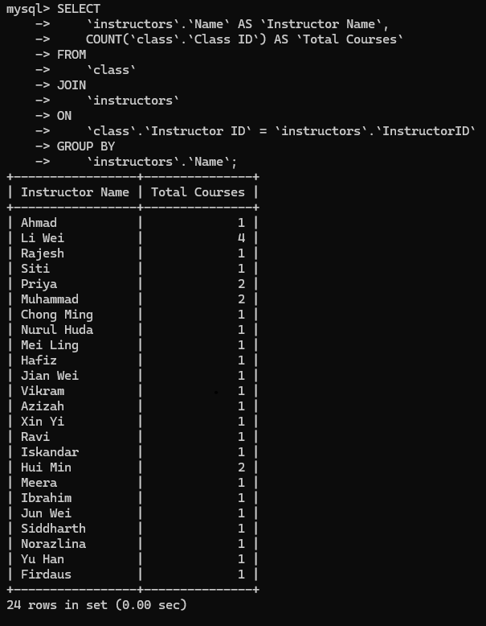

3.5.1Report Overview
The purpose of this report is to count the total number of courses taught by coaches in the fitness center, to help management understand the coaches' workload and course schedule, so as to optimize resource allocation, improve course quality and member satisfaction.

3.5.2Report Analysis
Workload distribution of coaches: From the data we have obtained, we can observe that there are certain differences in the number of courses each of our coaches is responsible for. Some coaches are responsible for significantly more courses than other coaches. Based on this situation, it can be concluded that the workload of these coaches is relatively large.
Utilization of coaching resources: We have counted the number of courses completed by each coach through a table, so that we can objectively evaluate the efficiency of each coach's utilization of course resources, so as to identify and reject some resource waste and overuse problems that may exist in the work.
Analysis of potential problems: The imbalance in the number of courses each coach is responsible for may cause some coaches to have excessive workloads and fatigue, while other coaches cannot give full play to their energy and teaching ability. The occurrence of this situation is likely to affect the quality of the courses we publish and the satisfaction of our members with the quality of the courses.

3.6 Identify the instructors who will teach the most courses in 2023
SELECT i.Name, COUNT(*) AS CourseCount
FROM attendance a
JOIN class c ON a.`ClassID` = c.`ClassID`
JOIN instructors i ON c.`InstructorID` = i.`InstructorID`
WHERE a.Date LIKE '2023%'
GROUP BY i.Name
ORDER BY CourseCount DESC
LIMIT 1;
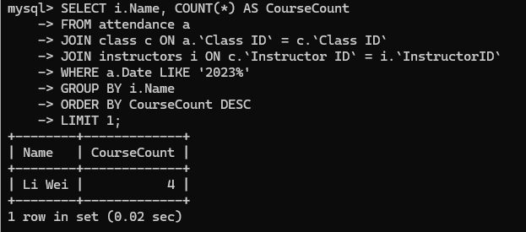

3.6.1 Report Overview
This query analyzes the coaches with the most courses in 2023 and returns the coaches with the most courses and their number of courses.

3.6.2 Report Analysis
Analysis of the activity of fitness center coaches:
Our analysis of the data table shows that the number of courses that Coach LI Wei participated in in 2023 is the largest among all coaches, which shows that Coach Li Wei is the most active in our fitness center, and of course, this also means that his workload has reached a high level. Such a high work intensity means that this coach may need us to list additional support and different management strategies to ensure and maintain the normal level of the coach's work and teaching efficiency and physical health.
Analysis of members' demand and popularity for courses:
According to the data table analysis of our fitness center, the number of courses taught by Coach Li Wei has reached the largest number, which shows that the courses taught by this coach have reached a high level of demand among our member groups, and can also reflect the popularity of the courses we set and the degree of popularity among members. The subsequent management of our fitness center needs data such as the popularity and popularity of the courses set to adjust and change the arrangement of the next courses, so as to ensure that the fitness needs of our members can be better met, and the quality of the courses and the richness of the courses can be pursue

3.7 Provide a point accrual trend for different member types and activities (class attendance, rentals, PT sessions) across brands. Identify members with the highest point balances and their preferred point earning methods.
SELECT `Member ID`, `Member Name`, SUM(`Activity Points`) AS TotalActivityPoints,
SUM(`Rental Equipment points`) AS TotalRentalEquipmentPoints, SUM(`Private Lesson points`) AS TotalPrivateLessonPoints
FROM `gyms`.`points system`
GROUP BY `Member ID`, `Member Name`
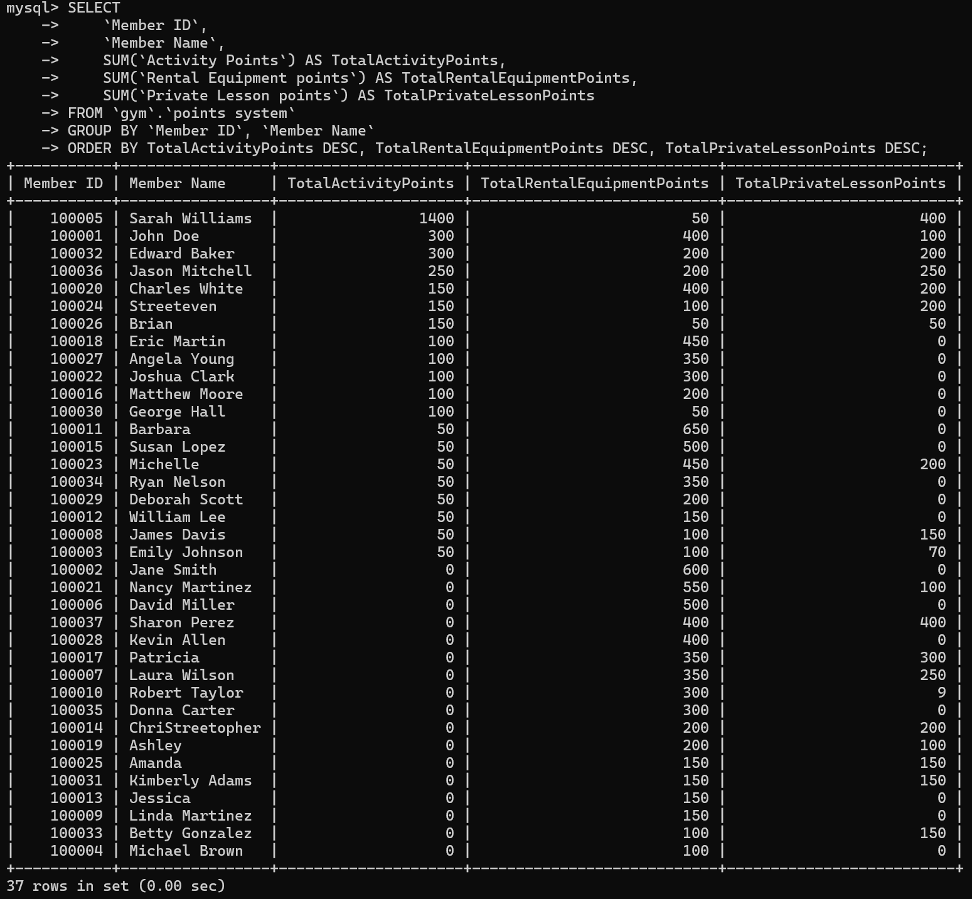
ORDER BY TotalActivityPoints DESC, TotalRentalEquipmentPoints DESC, TotalPrivateLessonPoints DESC;

SELECT `Member ID`, `Member Name`, SUM(`Activity Points`) AS TotalActivityPoints,
SUM(`Rental Equipment points`) AS TotalRentalEquipments,
SUM(`Private Lesson points`) AS TotalPrivateLessonPoints,
SUM(`Points Redemption`) AS TotalPointsRedemption
FROM `gyms`.`points system`
GROUP BY `Member ID`, `Member Name`
ORDER BY TotalActivityPoints DESC, TotalRentalEquipments DESC, TotalPrivateLessonPoints DESC, TotalPointsRedemption DESC
LIMIT 1;
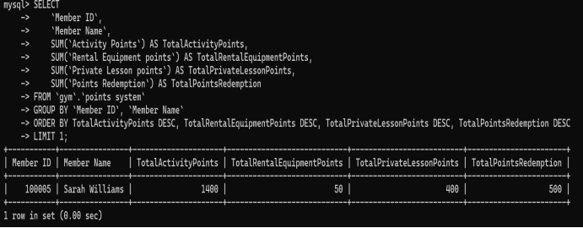

3.7.1 Report Overview
This report provides a holistic view to help fitness centers understand members’ activity participation and preferences. By analyzing this data, more effective member engagement strategies and personalized services can be developed to improve member satisfaction and fitness center operational efficiency.
This report extracts each member's total activity points, total rental equipment points, total private lesson points, and total points redeemed from the points system table in the gyms database, sorts the results in descending order of those totals, and then displays only the top-ranked member's information.

3.7.2 Report Analysis
Observation of VIP members:
What we have done is to show the members with the highest participation in our fitness center activities based on the accumulated points. This member has shown a high level of participation in all activities in our fitness center, including points earned from equipment rentals and private lessons with coaches, and has also used the redeemed points effectively.
Strategies that our fitness center should observe and use in the next operation:
The first step is that our fitness center should have a deeper understanding of the usage preferences of VIP members in the fitness center, so that more professional guidance and more personalized services can be customized for such members.
Develop more personalized activity strategies based on the specific preferences of VIP members. Optimize the service items and strategies of our fitness center and future updates of facilities to keep consistent with the popular items of the fitness center's customers. Implementing retention strategies such as these can increase the loyalty of the members we have. By leveraging insights from our statistical data, we can understand and implement support for fitness centers to improve operational efficiency through tailored VIP member activity participation strategies and service optimization.

3.8 Identify the top three best-selling packages (considering both Fit & Fab and Silver Sneakers) and analyze any correlations with brand associations or guest pass usage.
SELECT p.PackageID, p.`Package name`, COUNT(m.MemberID) AS PackageSales,
p.Brands
FROM member m JOIN package p ON m.PackageID = p.PackageID
WHERE m.Brands IN ('Fit & Fab', 'Silver Sneakers', 'Both')
GROUP BY p.PackageID, p.`Package name`, p.Brands
ORDER BY PackageSales DESC
LIMIT 3;
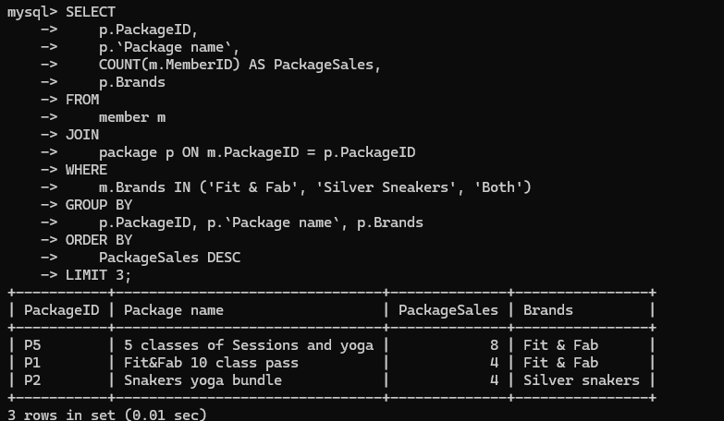

3.8.1 Report Overview
We can get the information of the top three packages with the highest sales volume, including package ID, package name, sales quantity and corresponding brand

3.8.2Report Analysis
The characteristics of the best-selling packages we found: From the sales data table, we can get the results that "Fit & Fab 10-class pass" and "Silver Sneakers yoga bundle" are the most popular packages among our customers, which shows that these packages have a relatively high appeal among our target customers, so I can develop some new packages in addition to this package. According to some characteristics of the previous best-selling packages, we can develop some new packages similar to it, so as to meet the individual needs of more of our members. For example, the gym launches more combination packages for sale, and the new packages will cover various types of fitness courses and private tutorials.
Some user preferences for brands: We can get user preferences for different brands from the data table. For example, Fit & Fab users prefer the 10th class package, while Silver Sneakers users prefer our yoga package, etc. In this way, we can use a cross-selling strategy in addition to these packages: use the influence of our already best-selling packages to conduct a cross-selling. For example, members who have purchased the best-selling package can get additional discount coupons for other related courses and related services, which will improve the overall sales performance.
Comprehensive package: Ultimate Fitness Package is a package for users of both brands. It also shows good sales performance, which shows that it has a certain popularity among users of both brands. We need to collect our members' opinions and suggestions on the various packages that have been released regularly to achieve feedback, and this can further realize some of the members' requirements and expectations of us, so that the adjustment and optimization of the package content can be more in line with reality and better meet the needs of members.

3.9：Identify the most successful “bring a friend” campaigns by analyzing which members refer new members (covering all membership types) and the points earned.
SELECT ps.`Member ID`,m.`Name`,m.`Email`,m.`VipStreetatus`,
(ps.`Activity Points` + ps.`Private Lesson points` + ps.`Course Points` + ps.`Rental Equipment points` - ps.`Points Redemption`) AS TotalPoints,m.`Registration Time`,ps.`Activity Points`,ps.`Private Lesson points`,ps.`Course Points`,ps.`Rental Equipment points`,ps.`Points Redemption`
FROM `points system` ps JOIN `member` m ON ps.`Member ID` = m.`MemberID`
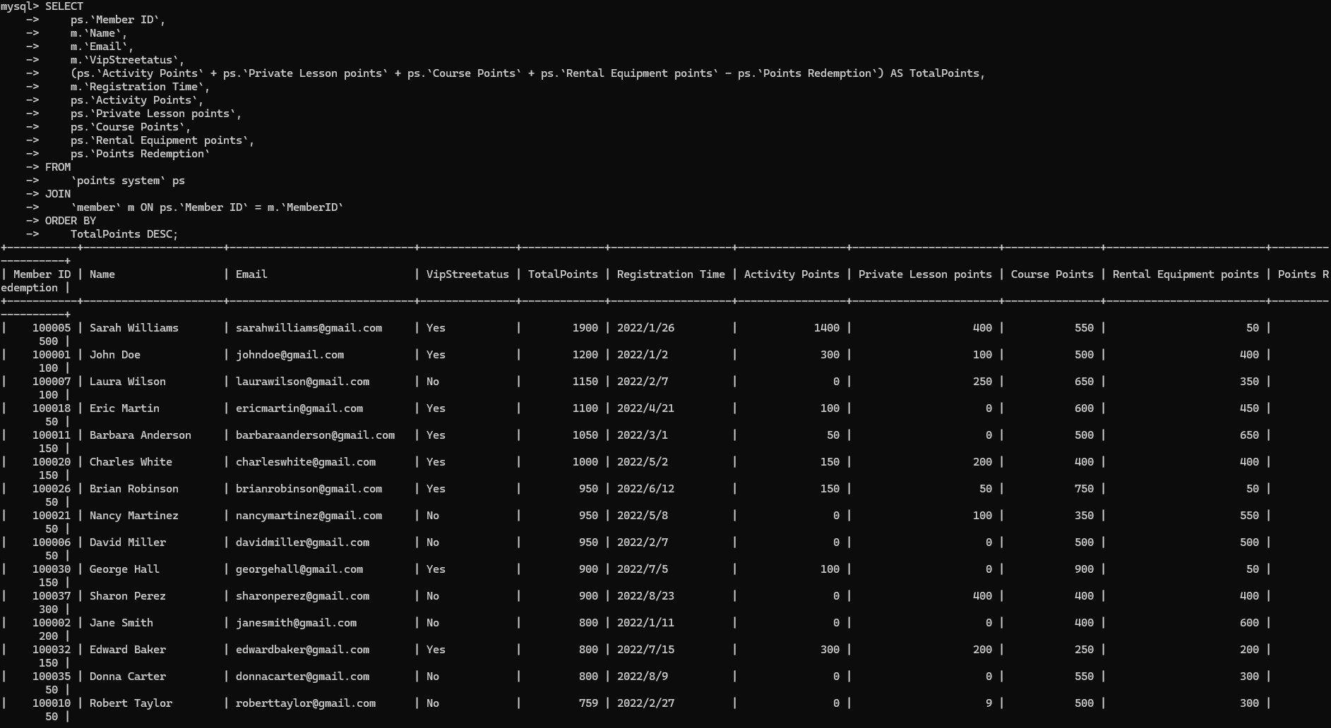
ORDER BY TotalPoints DESC;
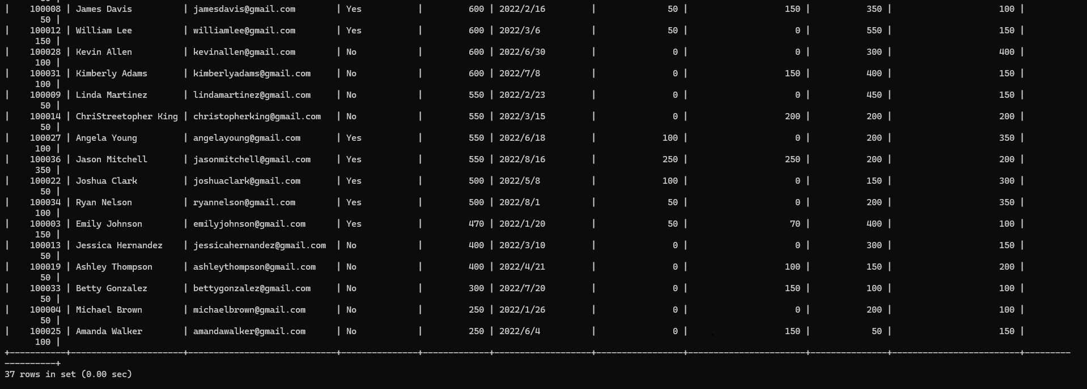

3.9.1 Report Overview
The objective of this report is to analyze the membership points system of a fitness center, focusing on the detailed breakdown of points accumulated by members, their VIP status, and the overall ranking based on total points. This report aims to provide insights into member engagement, participation in various activities, and the effectiveness of the current points system.

3.9.2Report Analysis
①Members' analysis of the structure of points: We can see from the data table that the total points are a combination of points obtained from activities, points accumulated from private courses, points from participating courses, and points obtained from equipment rental, minus the part they consumed through point redemption. Analyzing the trend of points acquisition will help us understand the specific direction of our members' participation and loyalty. It prompts us to establish a feedback mechanism for member information, which is related to collecting members' suggestions and expectations for various activities, specific courses, and equipment management initiated by us. We will improve our service content and design concepts for new activities, thereby improving our gym members' experience of equipment and satisfaction with services.
②Analysis of the performance of points for gym VIP members: The final total points of our VIP members are generally higher than those of other members, which indirectly shows that they are more enthusiastic and active in participating in activities and various types of courses. This shows that the loyalty and satisfaction of our VIP members are relatively high, and it is more worthy for us to focus on their opinions to maintain their satisfaction. Next, we will enhance the VIP member welfare activities, which will be more friendly to VIP members. We will launch more exclusive benefits for VIP members, such as priority booking of course equipment, etc., as well as irregular VIP exclusive activities, so that their enthusiasm will not be reduced and their satisfaction will not be exhausted. At the same time, we can also set up point rewards exclusively for VIP members. The set prizes can encourage and attract more members to upgrade to VIP members.
Regarding the relationship between the time of registration and the points obtained: We analyze the growth of members' points through the registration timetable. It is concluded that members who register earlier usually have a highe

3.10 Analyse the "class satisfaction scores" data to identify trends in member preferences and suggest improvements to class offerings based on brand, intensity level, and user feedback.
SELECT `Class Name`, AVG(`Satisfaction Rating`) AS AverageSatisfactionRating
FROM class
GROUP BY `Class Name`
ORDER BY AverageSatisfactionRating DESC;
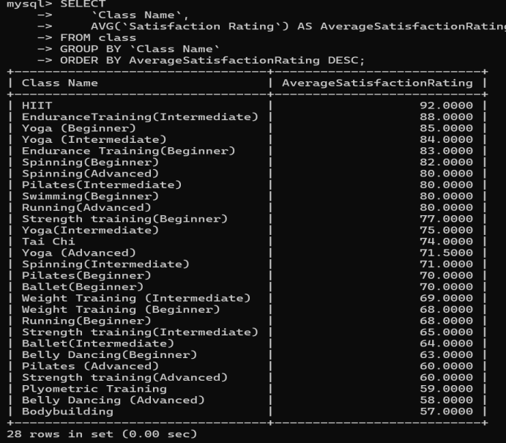
SELECT SUBSTRING_INDEX(`Class Name`, '(', 1) AS Brand,AVG(`Satisfaction Rating`) AS AverageSatisfactionRating
FROM class
GROUP BY Brand
ORDER BY AverageSatisfactionRating DESC;
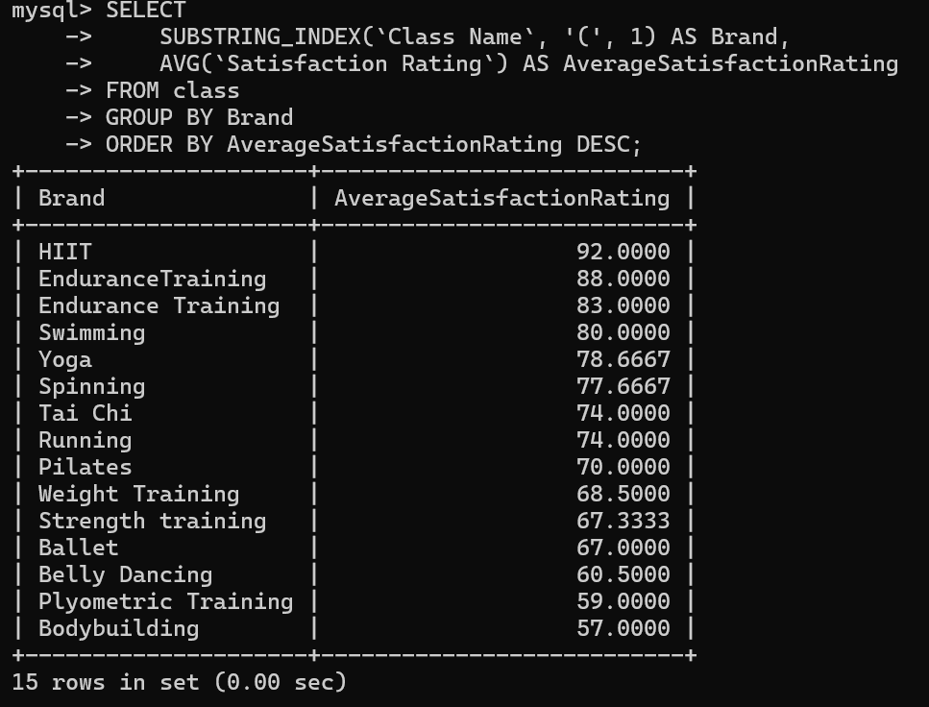
SELECT CASE
WHEN `Class Name` LIKE '%Beginner%' THEN 'Beginner'
WHEN `Class Name` LIKE '%Intermediate%' THEN 'Intermediate'
WHEN `Class Name` LIKE '%Advanced%' THEN 'Advanced'
ELSE 'Other' END AS IntensityLevel, AVG(`Satisfaction Rating`) AS AverageSatisfactionRating
FROM class
GROUP BY IntensityLevel
ORDER BY AverageSatisfactionRating DESC;
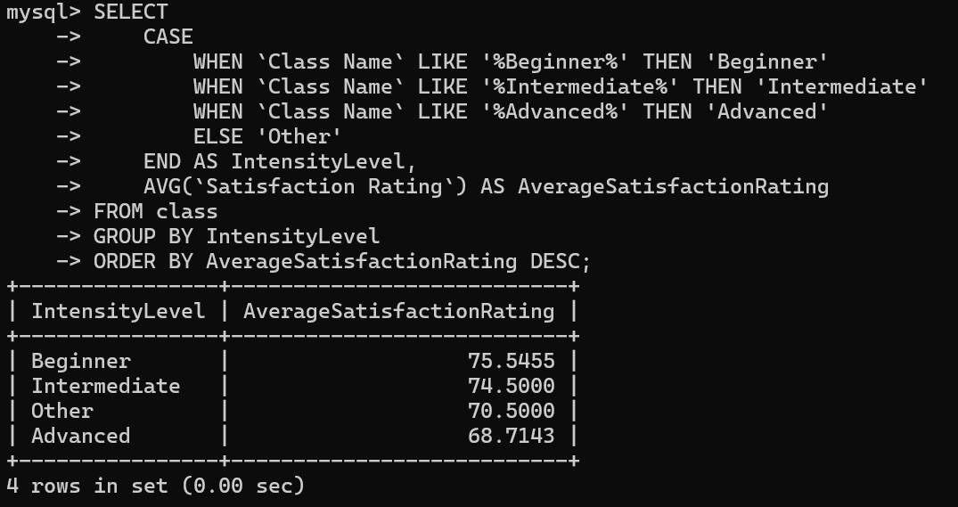

3.10.1Report Overview:
Our report analyzes the average satisfaction ratings of all private training courses at our fitness center. By analyzing the data in these tables, we can understand the satisfaction of different members with different courses. Through the analysis of these satisfaction, we can draw conclusions to help our fitness center optimize the arrangement of subsequent courses, so as to improve the satisfaction of existing members and their participation in courses.
This report provides the average satisfaction ratings of members for different brands of fitness courses at our fitness center. By analyzing and mining these data, our fitness center can better understand the trend of members' overall satisfaction ratings for courses under our existing brands, so that we can optimize course arrangements and content in the next operation.
Through detailed analysis of the data tables, we learned about the courses of various difficulty levels, and then evaluated all members' preferences and satisfaction with the courses we offered. This helped our fitness center to adjust its development concept and improve the overall experience quality of all members in the fitness center.

3.10.2Report Analysis
(1).This report shows the average satisfaction ratings of our members for each class in our fitness center.
HIIT and Yoga (Beginner) are the most popular classes among our members, and their average satisfaction ratings are the highest. This shows that our members are very satisfied with the quality and experience of these classes.
The satisfaction ratings of classes such as Plyometric Training and Endurance Training (Intermediate) are also high, which shows that these classes are also recognized by our fitness center members.
The satisfaction ratings of classes such as Bodybuilding and Belly Dancing (Advanced) are low, which may be because the teaching content of these classes or the teaching methods of the coaches do not meet the members' expectations.
There are also some classes with particularly low satisfaction ratings, such as Belly Dancing (Advanced) and Plyometric Training, which requires our fitness center to look for the reasons more carefully, and to change the content of the classes in the subsequent class arrangement plan or consider changing the coaching coaches to improve the teaching quality of this type of classes.
Based on the results of the above analysis, our fitness center can focus on promoting more courses with high member satisfaction scores, such as HIIT and Yoga (Beginner), etc. At the same time, we should also adjust or rectify courses with lower satisfaction scores, so as to improve our members' overall satisfaction with the courses.

(2). According to this report, our fitness center can analyze the results of this data and draw conclusions. Then we need to focus on brands with high satisfaction scores, and still improve and optimize brands with medium and low satisfaction scores, considering the overall situation of the fitness center to improve overall member satisfaction.
(3).The analysis of our data shows the satisfaction ratings of the members of the fitness center for the different intensity levels of the courses we have divided.
The average satisfaction rating of the beginner courses (Beginner) reached the highest, which shows that this type of course is the most popular type among our members. One possibility is that they are more suitable for novices and beginners to master and learn.
Intermediate courses (Intermediate) are below, which also shows that the members of our fitness center are also relatively satisfied with these types of courses, because these courses may be quite challenging, but the difficulty of this challenge is moderate, not to the extent that it is completely impossible to complete, but to give you a degree of difficulty but can be overcome, because they provide moderate challenges to members.
The satisfaction rating of advanced courses (Advanced) is the lowest, because they have higher requirements for members, and it is very difficult for members to learn and practice these courses. The high threshold will make most members less satisfied with this type of course.
The satisfaction rating of unclassified courses (Other) is the lowest, because this type of course may not meet the expectations of most of our members.
According to our series of data analysis results, our fitness center can increase the number of elementary and intermediate courses in the next course planning, or adjust the difficulty of advanced courses or the teaching philosophy of coaches to better meet the actual situation of most members. In addition, unclassified courses need to be discussed to further evaluate and optimize the content of the determined courses to meet the expectations of members and improve member satisfaction with the courses.

3.11 Uncover the secrets of member engagement! List the members who earned the most points in the past quarter, categorized by points earned through exercise, challenges, and healthy eating habits
SELECT ps.`Member ID`, m.`Name`, SUM (ps.`Activity Points`) AS TotalActivityPoints,
SUM (ps.`Private Lesson points`) AS TotalPrivateLessonPoints,
SUM (ps.`Course Points`) AS TotalCoursePoints,
(SUM(ps.`Activity Points`) + SUM(ps.`Private Lesson points`) + SUM(ps.`Course Points`)) AS TotalPoints
FROM `points system` ps INNER JOIN `member` m ON ps.`Member ID` = m.`MemberID`
WHERE ps.`Member ID` IS NOT NULL AND ps.`Activity Points` IS NOT NULL AND ps.`Private Lesson points` IS NOT NULL AND ps.`Course Points` IS NOT NULL
GROUP BY ps.`Member ID`, m.`Name`
ORDER BY TotalPoints DESC
LIMIT 1;
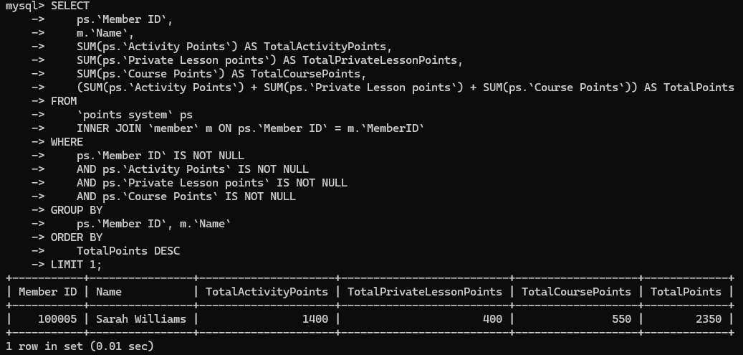

3.11.1Report Overview
We can get the information of the member with the highest accumulated points among all members, including detailed data of activity points, private course points and course point

3.11.2 Report Analysis
Member participation:
Based on the ranking of total points, we can analyze which members have the highest participation and enthusiasm, and these members will be more active in various activities in the fitness center. Based on the source of members' points, we can recommend activities that they may be interested in. For example, for members who earn points through private courses, we can recommend more personal training plans.
Points source:
Activity points, private course points, and course points can be counted separately to understand and become familiar with the contribution of different activities to point accumulation, and then adjust the incentives for the activities. At the same time, gamification elements can be introduced, and hierarchical systems, badges, and achievement systems can be introduced to make the point accumulation process more interesting and challenging, and further stimulate members' enthusiasm for participation. If you find that relatively few points are earned in certain activities, you can consider increasing the point rewards for these activities to encourage members to participate more in these activities.

4 ANALYSING DATABASE STRUCTURE AND DESIGNING USEFUL REPORTS
Prepare Five (5) different types of reports using SQL query language. These reports should indicate the students in the group are able to analyse the data stored in various tables and they should provide in-depth insights for the fitness center. The mark allocation for this section is based on the complexity and ability of students to analyse the data recorded in various tables.

4.1Member points accumulation report
SELECT m.MemberID, m.Name AS MemberName, ps.₊`Activity Points` ps. +`Private Lesson points` +ps.`Course Points` +ps.`Rental Equipment points` -ps.`Points Redemption` AS TotalPoints
FROM member m LEFT JOIN `points system` ps ON m.MemberID = ps.`Member ID`;
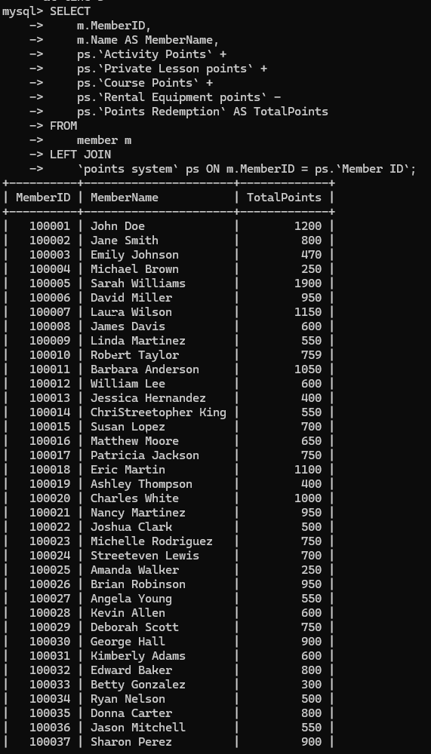
SELECT
COUNT(ps.`Member ID`) AS TotalMembers, SUM(ps.`Activity Points` + ps.`Private Lesson points` + ps.`Course Points` + ps.`Rental Equipment points` - ps.`Points Redemption`) AS TotalPoints, AVG(ps.`Activity Points` + ps.`Private Lesson points` ps.`Course Points` + ps.`Rental Equipment points` - ps.`Points Redemption`) AS AvgPoints FROM `points system` ps;
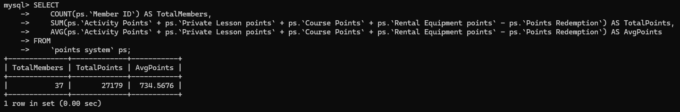

4.1.1 Report Overview
Member engagement analysis: Understand each member's participation in different activities and courses, and evaluate their activity and fitness plan execution.
Personalized service optimization: Provide personalized fitness advice and services based on the member's total points and participation to improve member satisfaction and loyalty.
Member incentives and rewards: Based on the member's points performance, design incentive plans and reward mechanisms to promote members' long-term participation and the achievement of fitness goals.②This report provides an overview of the points system, covering statistics and analysis in the following areas:
Total Members: The total number of members currently in the points system.
Total Points: The sum of all members' accumulated points, including activity points, private lesson points, course points, rental equipment points minus redemption points.
Average Points: The average of all members' points, reflecting the general level of activity of members in earning and using points.

4.1.2 Report Analysis
Calculation of points for members recommended by our fitness center:
First, we need to query and use the IFNULL function to handle the situation where the points value may be empty, so as to further ensure the integrity and accuracy of our calculation of member points. This method can also more effectively add up the various points items of all members, and then subtract the points that the members have consumed through redemption, so that the final total points of each member can be correctly calculated in the end.
How should we ensure the integrity of the obtained data:
We need to use LEFT JOIN to make a strong connection between the member table and the points system table, so that if the relevant points data of some members is lost, we can still correctly arrange the total points of all members after calculation. This will help the managers of our fitness center to understand the total points of all our members more comprehensively and intuitively, and the integrity of the table of points data will not be affected.
About the application of fitness center related business:
Through the total points data table obtained by the above calculations, we can analyze the activity level and participation level of courses and activities generated by each member of the fitness center. The high-point members generated by this will be our loyal customers, which deserves our special attention and certain incentives; members with lower points need us to give them additional participation encouragement or targeted personalized service recommendations, so that our fitness center can improve their membership experience and increase their loyalty to our fitness center.
Suggestions for fitness center management:
Optimization of personalized business-related services: We need to formulate personalized and targeted enhanced services and more relevant promotion strategies for member groups with different points according to the level of points obtained by members, so as to increase the participation of the majority of members
The total number of members can help you understand the size of the membership base, which helps you assess the impact and reach of the points system.
The average points reflect how active members are in earning and using points. A relatively high average points may indicate that members are more interested in the points reward system and are willing to actively participate.
Member Activity Analysis: We'll look at total activity points to see which types of members are the most active in our fitness center compared to others.
Equipment Usage Analysis: By examining points generated from equipment rentals, we can see which fitness equipment types members use the most.
Private Coaching Participation Analysis: Analyzing points from private coaching sessions will show us how often and enthusiastically members participate in these one-on-one courses at the fitness center.

4.2 Equipment Utilization Report
This report will show how equipment is utilized across the fitness center.
SELECT e.EquipmentID AS `Equipment ID`,e.EquipmentName AS `Equipment Name`,
e.AvailabilityStatus AS `Availability Status`,e.`Rentmemberid` AS `Rent Member ID`,
m.Name AS `Rent Member Name`
FROM equipment e
LEFT JOIN member m ON e.`Rentmemberid` = m.`MemberID`
WHERE e.AvailabilityStatus = 'Rented' OR e.AvailabilityStatus = 'Available';
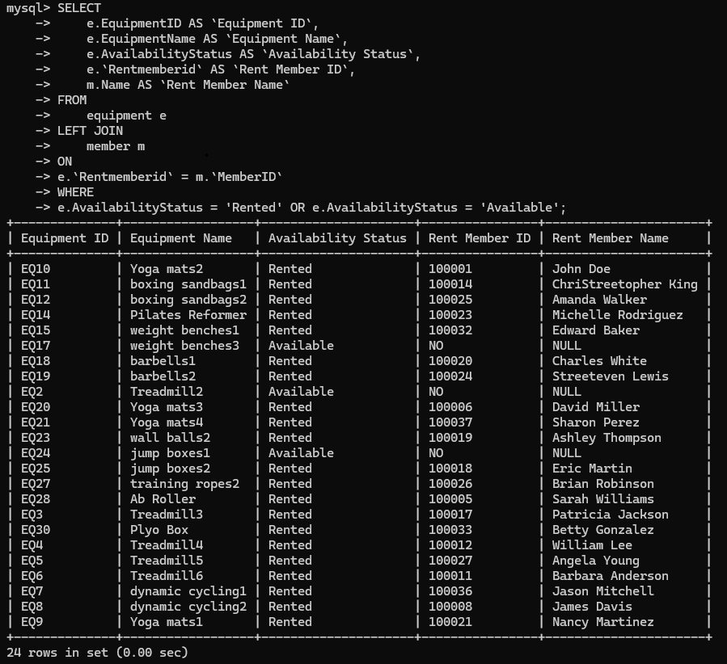

4.2.1 Report Overview
This report analyzes the rental status of fitness center equipment, including the availability of equipment, rental member information, and rental fees. These data help managers understand the use of equipment and optimize equipment management and maintenance strategies.

4.2.2 Report Analysis
① Equipment usage preference:
From the table, we can see that members tend to rent more equipment on one side than on the other, so the number of equipment is determined based on the member's preference. For members who frequently rent equipment, we can provide member-exclusive discounts or packages to improve member satisfaction.
②Membership rental status:
Some members frequently rent equipment, indicating that they have a high demand for specific equipment. You can consider increasing the number of corresponding equipment.
Equipment usage:
Most of the equipment is in rental status, indicating high utilization rate, but some equipment is under maintenance, indicating that regular maintenance and management are required.

4.3 Membership Type Analysis Report
This report will analyze the distribution of membership types among members.
SELECT `Brand`, `Membership type`,COUNT(*) as member_count
FROM `membership type`
GROUP BY `Brand`, `Membership type`
ORDER BY`Brand`,`Membership type`;
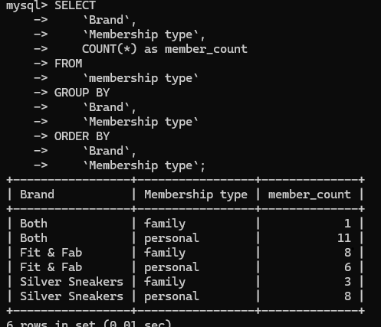

4.3.1 Report Overview
This report is used to analyze the brand preferences and membership type distribution of fitness center members. By studying these data analyses, fitness centers can understand the popularity of different brands and membership types, and then improve and increase membership services and marketing strategies.

4.3.2 Report Analysis
① Member distribution:
Investigate and analyze the coverage of various membership types under different brands to understand which brands have more members.
② Member type popularity:
Compare the number of membership types of different brands to understand which membership types are more popular, so as to formulate and improve more targeted marketing strategies.
③ Market positioning:
Based on the distribution of different brands and membership types, as well as the number of members under each brand and membership type, it reflects the popularity of each brand and type.conduct market positioning and brand promotion.

4.4 Instructor Satisfaction Analysis Report
This report will analyze the satisfaction ratings of instructors based on their classes.
SELECT i.InstructorID AS 'Instructor ID',i.Name AS 'Instructor Name', AVG(CONVERT(SUBSTRING_INDEX(a.Rate, '%', 1), DECIMAL(5, 2))) AS 'Average Satisfaction Rating (%)',COUNT(DISTINCT a.`Class ID`) AS 'Number of Classes',
COUNT(a.AttendanceID) AS 'Total Attendance Records'
FROM attendance a JOIN class c ON a.`Class ID` = c.`Class ID` JOIN instructors i ON c.`Instructor ID` = i.InstructorID
GROUP BY i.InstructorID, i.Name
ORDER BY `Average Satisfaction Rating (%)` DESC;
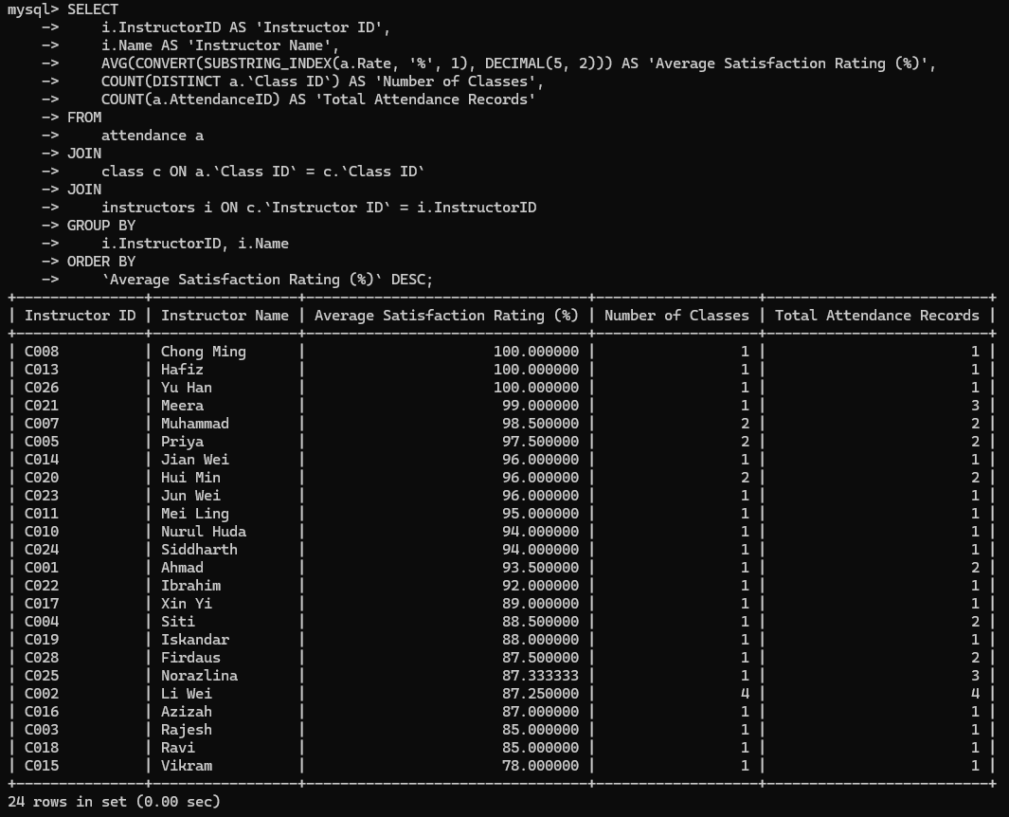

4.4.1Report Overview
Our report analyzes the satisfaction scores of fitness center coaches, the number of coaching courses, and the total attendance records. Through the analysis of these data, we can understand the performance of coaches and provide a basis for the operation decision of the fitness center.

4.4.2Report Analysis
①Average satisfaction: We analyze the average satisfaction of lecturers so that everyone can understand which lecturers are popular with members, which helps to commend excellent lecturers, improve the teaching quality of other lecturers and, to a certain extent, make the teacher more confident to teach everyone
②Number of classes: Analyze the number of lecturers' lectures, investigate the workload and number of courses of each lecturer, and then make reasonable course arrangements and resource allocation.
③Total attendance record: The total attendance record reflects the popularity of the lecturer's courses and can be used as a basis for course adjustment and optimization.

4.5 Sales Analysis Report
This report will analyze sales performance of different merchandise.
SELECT `Merchant Name` AS Merchandise, SUM(`inventory`) AS TotalInventory,
COUNT(*) AS NumberOfItems
FROM `merchant` GROUP BY `Merchant Name`
ORDER BY TotalInventory DESC
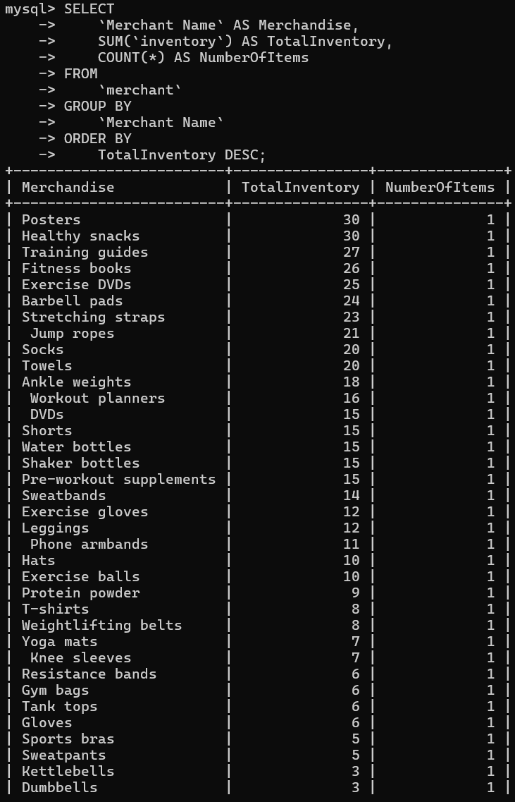

4.5.1 Report Overview
This report analyzes the inventory status of each merchant. By analyzing this data, we can understand the total inventory and number of product types of each merchant, which can provide meaningful improvements for the inventory management and purchasing decisions of fitness centers to a large extent.

4.5.2 Report Analysis
①Total inventory:
Analyze and investigate the total inventory of various merchants, investigate which brand merchants have a higher inventory than other brand merchants, and formulate and improve the corresponding inventory management methods.
②Comparison of the number of commodity types:
Investigate the number of different commodity types owned by various merchants, investigate which merchants have a higher inventory than other brand merchants, and optimize and improve the management of commodity types.
③Inventory management correction analysis:
Count the total inventory and the number of commodity types to help fitness centers arrange inventory reasonably and avoid inventory backlogs and out-of-stocks.

5. Unforeseen challenges:
16.The fitness center is considering offering outdoor fitness bootcamp sessions as a temporary measure due to unexpected construction work impacting the gym facilities. Discuss the potential database modifications and additional data capture requirements needed to accommodate this new offering.
The fitness center is considering offering outdoor fitness bootcamp sessions as a temporary measure due to unexpected construction work impacting the gym
Facilities discuss the potential database modifications and additional data capture
requirements needed to accommodate this new offering.
To accommodate the new outdoor fitness boot camp activities launched by the fitness center, modifications and additional data capture requirements should be considered. The following is a detailed discussion:
Sessions Table:

5.1 Create a new table to store information about outdoor fitness boot camp courses. It should contain:
session id(primary key): an ID that uniquely identifies each boot camp course.
date: the date of the course.
time: the time of the course.
location (outdoor location details): details of the outdoor location where the course is held.
Instructor id: an ID associated with the instructor table, indicating the instructor of the course.
Max participants: the maximum number of participants allowed for the course。
The statement to create a table is as follows: 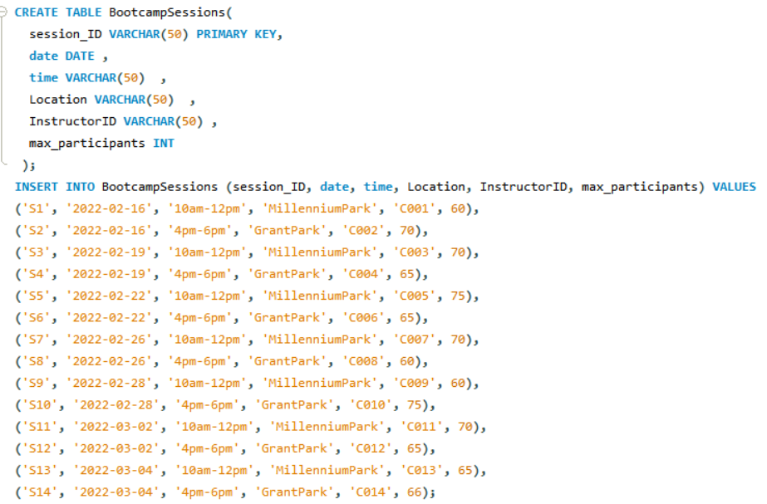
After inserting the data, the complete table is as follows:
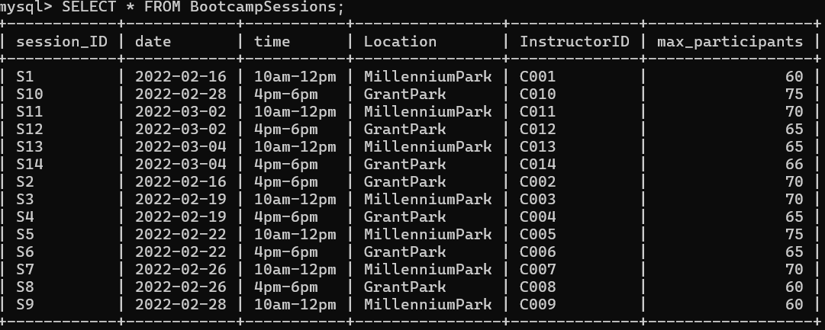

5.2 also need to create a new attendance table to record the attendance of members. It should contain：
attendance_ID：Represents the number of people signing in for each class and serves as the primary key。
Participants；Represents the number of participants in this class

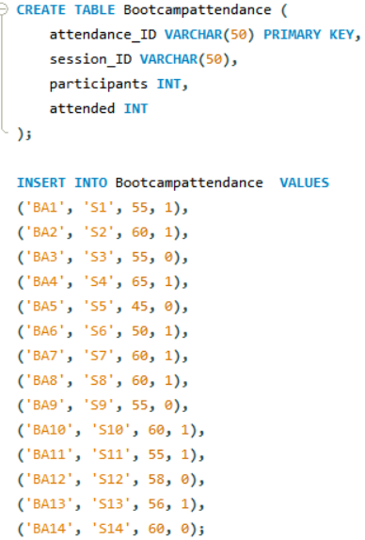
After inserting the data, the complete table is as follows:
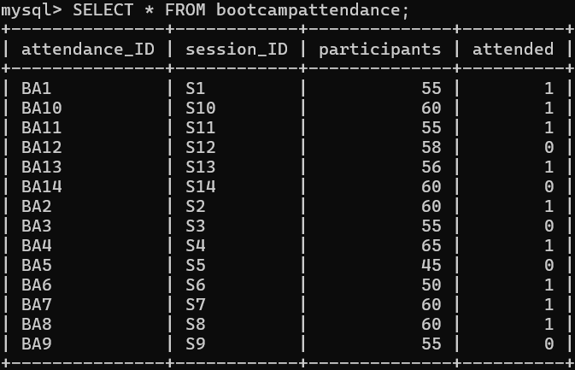

5.3 And we need to change the fitness machine table in mysql. Because some devices cannot be owned outdoors
We need to enter: update mysql statement
SELECT * FROM gyms.equipment;
UPDATE gyms.equipment
SET EquipmentName = 'dumbbel'
WHERE EquipmentName = 'Treadmill1';
UPDATE gyms.equipment
SET EquipmentName = 'bike'
WHERE EquipmentName = 'wall balls1'；
Picture 1 is the table before update
Picture 2 is the picture after entering the update statement
You can see that the yellow words have been updated
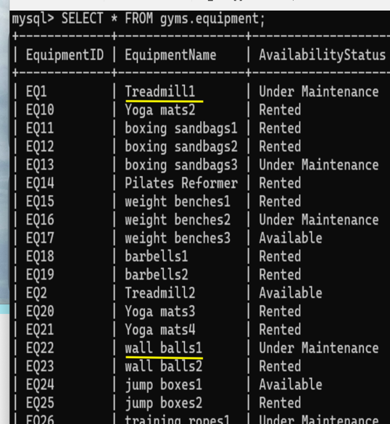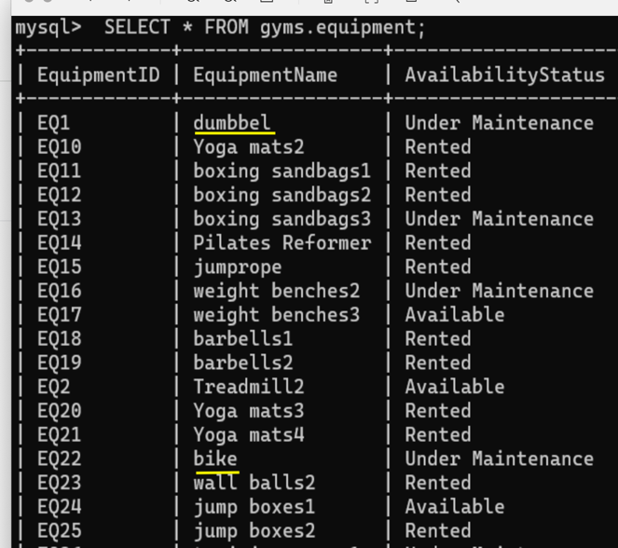

6.REFERENCE
Reference:
Business report writing
Munter, M., & Hamilton, C. (2013). Guide to Managerial Communication: Effective Business Writing and Speaking. Pearson.
This book introduces effective business writing and communication techniques that can help produce reports that are clear, concise, and impactful.

7.Prepare a video presentation for marketing purposes to attract more members to the fitness center and correlate it to Section D.
Requirements : Minimum – 2 minutes, no online videos, all members of the group should be seen in the video, must be uploaded in YouTube and the link should only be shared during the submission. Unique creative ideas will be awarded more marks.
https://youtu.be/2wVIZnlf5CM?si=PkDhyCf1PLjbtQ-a

Marks Tabulation process:
Student need to be aware that database design outcome effects the development process of the database. If the design is not being properly considered, then the implementation and roll-out carriers the effect of the database design. In the case of poor database design, a simple reduction of marks with design, will be carried to development as well. Incorrect and inaccurate design leads to incorrect and inaccurate development as well, even though the implementation is completed.

